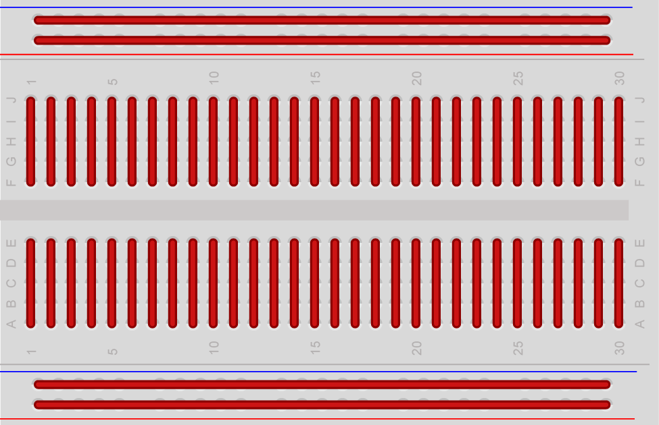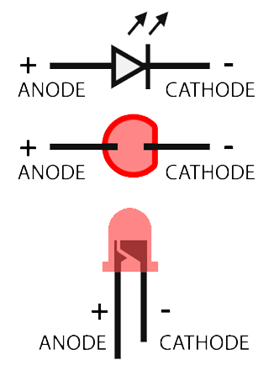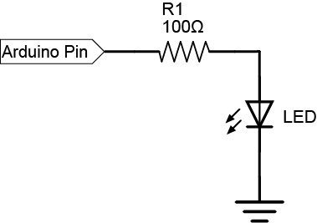Useful Diagrams

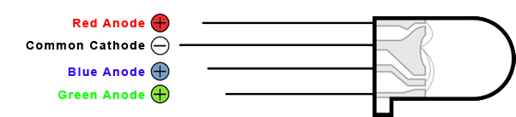

Code Reference

# Variable types:

|  |  |  |
| --- | --- | --- |
| Variable type | Description | |
| int | | A whole number with a value between -32,768 to 32,767 | |
| unsigned int | | The same as above but you can’t use negative numbers, it has to be between 0 and 65,535 | |
| long | | Same as an int but allows you to store larger values at the cost of using more memory. Has to be between -2,147,483,648 to 2,147,483,647. Like the int you can also precede it with unsigned if you don’t need negatives | |
| boolean | | A true or false value | |
| double | | A number with a decimal point e.g. 2.34 | |
| char | | A single character, e.g. ‘c’ | |
| string | | “This is an example of a string” | |

# Common functions

pinMode(int pin, int mode)

This function is used to set I/O pins on the Arduino to different modes. The modes available are INPUT, OUTPUT and INPUT_PULLUP.

The pin parameter refers to which pin you wish to change the mode of. These match the marking on the Arduino board, 0-13 and A0-A5. To make settings pin modes in loops easier A0-A5 can also be called 14-19.

digitalWrite(int pin, int state)

This function allows you to set the state of an output pin to either HIGH or LOW (5v and 0v in the case of an Arduino). If the pin is set to INPUT_PULLUP mode HIGH will enable the pull up resistor and LOW will disable it.

digitalRead(int pin);

This function returns the digital state of a pin that is set to INPUT mode. It will return either HIGH or LOW.

analogWrite(int pin, int value)

This function outputs a pulse width modulated signal that will be on for a certain percentage of the time. Value has to be an integer between 0 and 255 where 0 = on 0% of the time and 255 = on 100% of the time. The Only pins 3, 5, 6, 9, 10 and 11 can be used on the Arduino UNO for this.

delay(unsigned long milliseconds)

This function takes a positive number and will pause the Arduino sketch for that many milliseconds.